|  |
| --- |
| Electrical System Form FSAE-E2015 |
| The University of Akron |
| Akron Electric |
| Car E217 |
| [RCJ10@zips.uakron.edu](mailto:RCJ10@zips.uakron.edu) |

Table of Contents

Table of Contents iii

I List of Figures vii

II List of Tables viii

III List of Abbreviations ix

1 System Overview 2

2 Electrical Systems 3

2.1 Shutdown Circuit 3

2.1.1 Description / concept 3

2.1.2 Wiring/additional circuitry 3

2.1.3 Position in car 4

2.2 IMD 4

2.2.1 Description(type,operationparameters) 4

2.2.2 Wiring/cables/connectors/ 5

2.2.3 Position in car 5

2.3 Inertia Switch 5

2.3.1 Description(type,operationparameters) 5

2.3.2 Wiring/cables/connectors/ 5

2.3.3 Positionincar 5

2.4 Brake Plausibility Device 5

2.4.1 Description / additional circuitry 5

2.4.2 Wiring 6

2.4.3 Positionincar/mechanicalfastening/mechanicalconnection 6

2.5 Reset / LatchingforIMDandBMS 6

2.5.1 Description/circuitry 6

2.5.2 Wiring/cables/connectors 6

2.5.3 Position in car 6

2.6 Shutdown System Interlocks 7

2.6.1 Description/circuitry 7

2.6.2 Wiring/cables/connectors 7

2.6.3 Position in car 7

2.7 Tractive system active light 7

2.7.1 Description/circuitry 7

2.7.2 Wiring/cables/connectors 8

2.7.3 Position in car 8

2.8 Measurement points 8

2.8.1 Description 8

2.8.2 Wiring,connectors,cables 8

2.8.3 Positionincar 8

2.9 Pre-Charge circuitry 8

2.9.1 Description 8

2.9.2 Wiring,cables,currentcalculations,connectors 8

2.9.3 Position in car 9

2.10 Discharge circuitry 9

2.10.1 Description 9

2.10.2 Wiring,cables,currentcalculations,connectors 9

2.10.3 Position in car 10

2.11 HVDisconnect (HVD) 10

2.11.1 Description 10

2.11.2 Wiring,cables,currentcalculations,connectors 10

2.11.3 Position in car 10

2.12 Ready-To-Drive-Sound(RTDS) 11

2.12.1 Description 11

2.12.2 Wiring,cables,currentcalculations,connectors 11

2.12.3 Position in car 11

3 Accumulator 12

3.1 Accumulatorpack1 12

3.1.1 Overview/description/parameters 12

3.1.2 Cell description 12

3.1.3 Cell configuration 13

3.1.4 Cell temperature monitoring 13

3.1.5 Battery management system 13

3.1.6 Accumulator indicator 14

3.1.7 Wiring,cables,currentcalculations,connectors 14

3.1.8 Accumulator insulation relays 14

3.1.9 Fusing 15

3.1.10 Charging 16

3.1.11 MechanicalConfiguration/materials 17

3.1.12 Positionincar 17

3.2 Accumulator pack 2 17

4 Energy meter mounting 18

4.1 Description 18

4.2 Wiring,cables,currentcalculations,connectors 18

4.3 Position in car 18

5 Motorcontroller 19

5.1 Motorcontroller1 19

5.1.1 Description,type,operation parameters 19

5.1.2 Wiring,cables,currentcalculations,connectors 19

5.1.3 Position in car 20

5.2 Motor controller 2 20

6 Motors 21

6.1 Motor1 21

6.1.1 Description,type,operatingparameters 21

6.1.2 Wiring,cables,currentcalculations,connectors 21

6.1.3 Positionincar 22

6.2 Motor 2 22

7 Torque encoder 23

7.1 Description/additional circuitry 23

7.2 Torque Encoder Plausibility Check 23

7.3 Wiring 23

7.4 Positionincar/mechanicalfastening/mechanicalconnection 23

8 AdditionalLV-partsinterferingwiththetractivesystem 24

8.1.2 Wiring,cables, 24

8.1.3 Position in car 24

8.2 LVpart2 24

9 Overall Grounding Concept 25

9.1 Description of the Grounding Concept 25

9.2 Grounding Measurements 25

10 Firewall(s) 26

10.1 Firewall1 26

10.1.1 Description/materials 26

10.1.2 Positionincar 26

10.2 Firewall2 26

11 Appendix 27

# List of Figures

Has tobehyperlinked!

# List of Tables

[Table 1.1 General parameters 2](#_Toc399226735)

[Table 2.1 Listofswitchesinthe shutdown circuit 3](#_Toc399226736)

[Table 2.2 Wiring – Shutdown circuit 4](#_Toc399226737)

[Table 2.3 Parameters of the IMD 4](#_Toc399226738)

[Table 2.4 Parameters of the Inertia Switch 5](#_Toc399226739)

[Table 7.1 Torque encoder data 6](#_Toc399226740)

[Table 2.6 Parameters of the TSAL 7](#_Toc399226741)

[Table 2.7 General data of the pre-charge resistor 9](#_Toc399226742)

[Table 2.8 General data of the pre-charge relay 9](#_Toc399226743)

[Table 2.9 General data of the discharge circuit 10](#_Toc399226744)

[Table 3.1 Main accumulator parameters 12](#_Toc399226745)

[Table 3.2 Main cell specification 13](#_Toc399226746)

[Table 3.5 Wire data of company A, 0.205 mm² 14](#_Toc399226747)

[Table 3.3 Basic AIR data 15](#_Toc399226748)

[Table 3.4 Basic fuse data 15](#_Toc399226749)

[Table 3.5 Fuse Protection Table 16](#_Toc399226750)

[Table 3.6 General charger data 17](#_Toc399226751)

[Table 5.1 General motor controller data 19](#_Toc399226752)

[Table 5.2 Wire data of company A, 0.205 mm² 20](#_Toc399226753)

[Table 6.1 General motor data 21](#_Toc399226754)

[Table 7.1 Torque encoder data 23](#_Toc399226755)

Has tobehyperlinked!

# List of Abbreviations

* HV: High Voltage
* GLVS: Grounded Low Voltage System
* BMS: Battery Management System
* BMM: Battery Management System Master
* BMSS: Battery Management System Slave (S)
* SAS: Sensor Acquision System
* MCS: Motor Controller System
* SS: Safety System
* DDS: Dasboard Display System

# SystemOverview

The University of Akron’s electrical system concept splits the electrical system into the Tractive HV system, and the GLV control system. The tractive system includes the motors, motor controllers, batteries, AIR’s, main fuse, and part of the BMS. The GLV control system includes the control section of the BMS, sensors.

The vehicle is a single motor, rear wheel drive electric car. The motor is a79kW peak output power with a 3.5:1 gear ratio and a mechanical differential. Traction control is required to keep wheel slip to a minimum. The accumulator system consists of 280LiPo battery cells. They are connected in two accumulators that holds two 70 series sets.

Driver Input

Control System

Safty Circuit

BMS

AIR

Motor Controller

Motor

Accumulator

|  |  |
| --- | --- |
| Maximum Tractive-system voltage: | 294VDC |
| Nominal Tractive-system voltage: | 231VDC |
| Control-system voltage: | 24VDC |
| Accumulator configuration: | 70s4p |
| Total Accumulator capacity: | 28.2Ah6.46 kWatt-hours; 29.68MJ |
| Motor type: | Permanent Magnet Brushless AC |
| Number of motors: | One |
| Maximum combined motor power in kW | 79kW |

Table 1.1 General parameters

# ElectricalSystems

## Shutdown Circuit

### Description/concept

The shutdown circuit carries the current to open or close the Accumulator Isolation Relays, providing several methods for shutting down the high voltage parts of the car in emergencies. All the emergency switches are connected in series so if one switch opens, the whole system stops. The shutdown system also examines where the fault is to alert the team what faulted.

|  |  |
| --- | --- |
| Part | Function |
| Main Switch (for control and tractive-system; CSMS, TSMS) | Normally open |
| Brake over travel switch (BOTS) | Normally closed |
| Shutdown buttons (SDB) | Normally closed |
| Insulation Monitoring Device (IMD) | Normally closed |
| Battery Management System (BMS) | Normally closed |
| Inertia Switch | Normally closed |
| Interlocks | Closed when circuits are connected |
| Software system (ECU) | Normally closed |
| Brake System Plausibility Device | Normally Closed |

Table 2.1Listofswitchesintheshutdowncircuit

### Wiring/additional circuitry

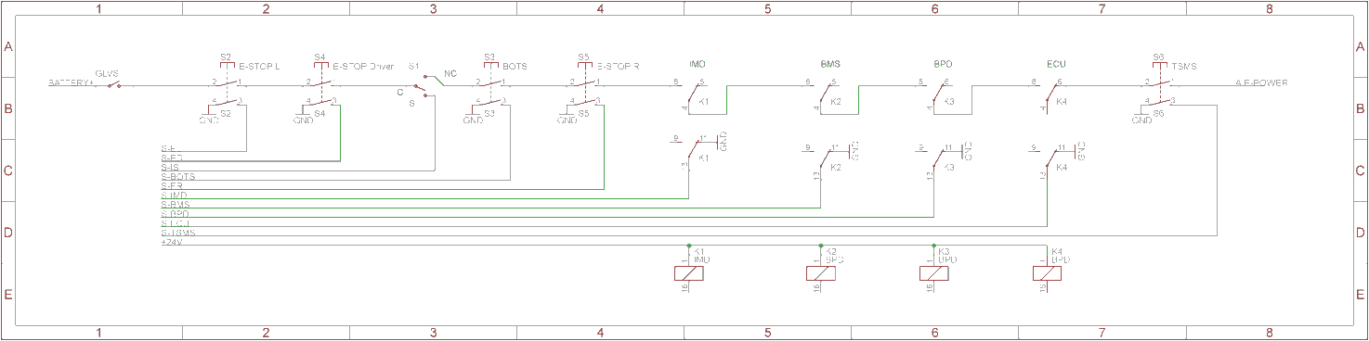

|  |  |
| --- | --- |
| Total Number of AIRs: | 4 |
| Current per AIR: | 0.250A |
| Additional parts consumption within the shutdown circuit: | 1A |
| Total current: | 2A |
| Cross sectional area of the wiring used: |  |

Table 2.2 Wiring – Shutdown circuit

### Position in car

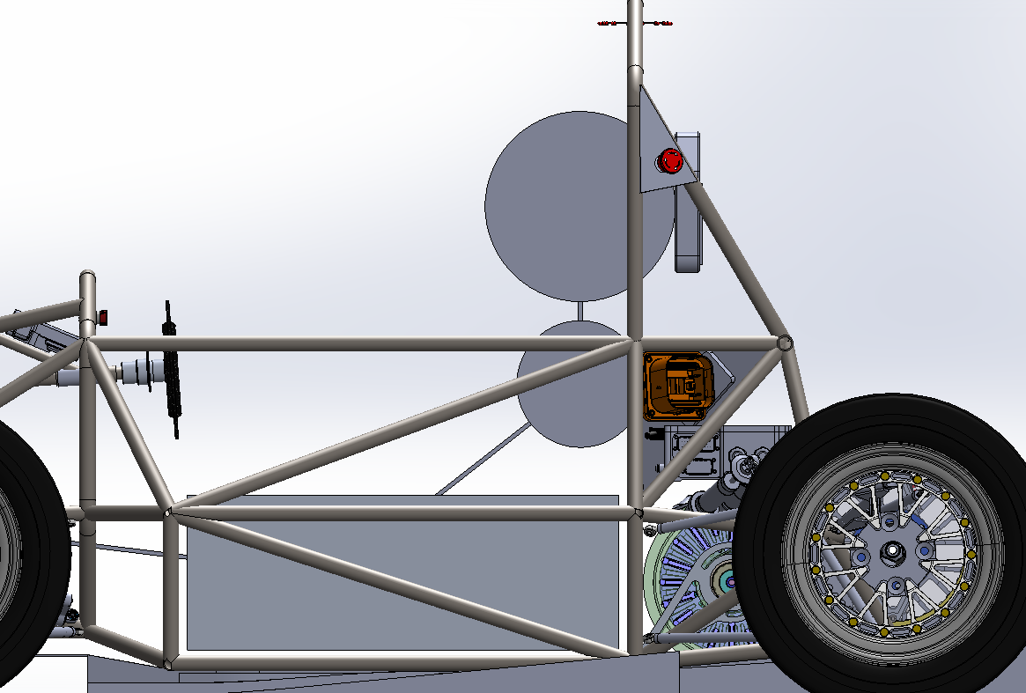

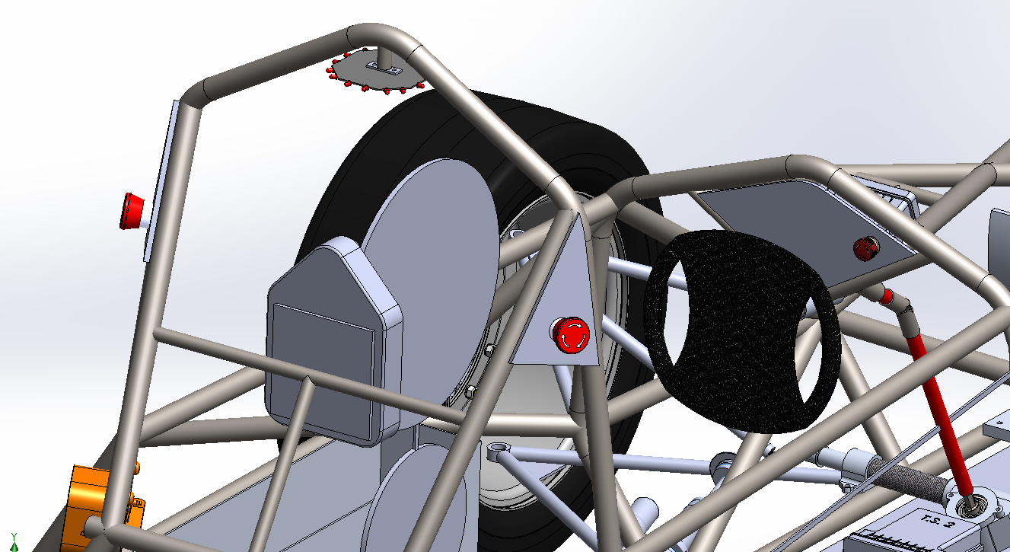

## IMD

### Description(type, operation parameters)

Bender A-Isometer IR-155-3203, Automatic Device Self-test and Continuous measurement of insulation resistance. The indicator is wired to the front dash. The LED is lit by a software cue from the safety system (SS) to the Dashboard Display System DDS controller warning the driver.

|  |  |
| --- | --- |
| Supply voltage range: | 10..36VDC |
| Supply voltage | 24VDC |
| Environmental temperature range: | -40..105°C |
| Selftest interval: | Always at startup, then every 20 minutes |
| High voltage range: | DC 0..1000V |
| Set response value: | 150kΩ (500Ω/Volt) |
| Max. operation current: | 500mA |
| Approximate time to shutdown at 50% of the response value: | 27s |

Table 2.3 Parameters of the IMD

### Wiring/cables/connectors/

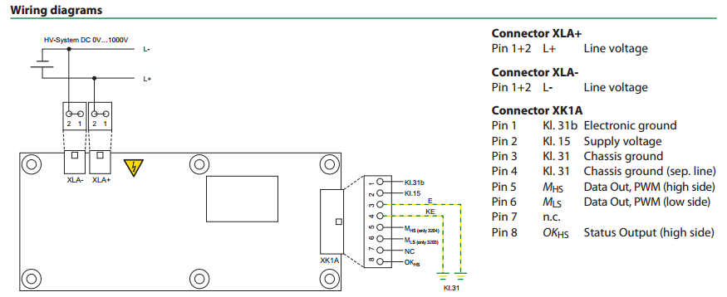

### Position in car

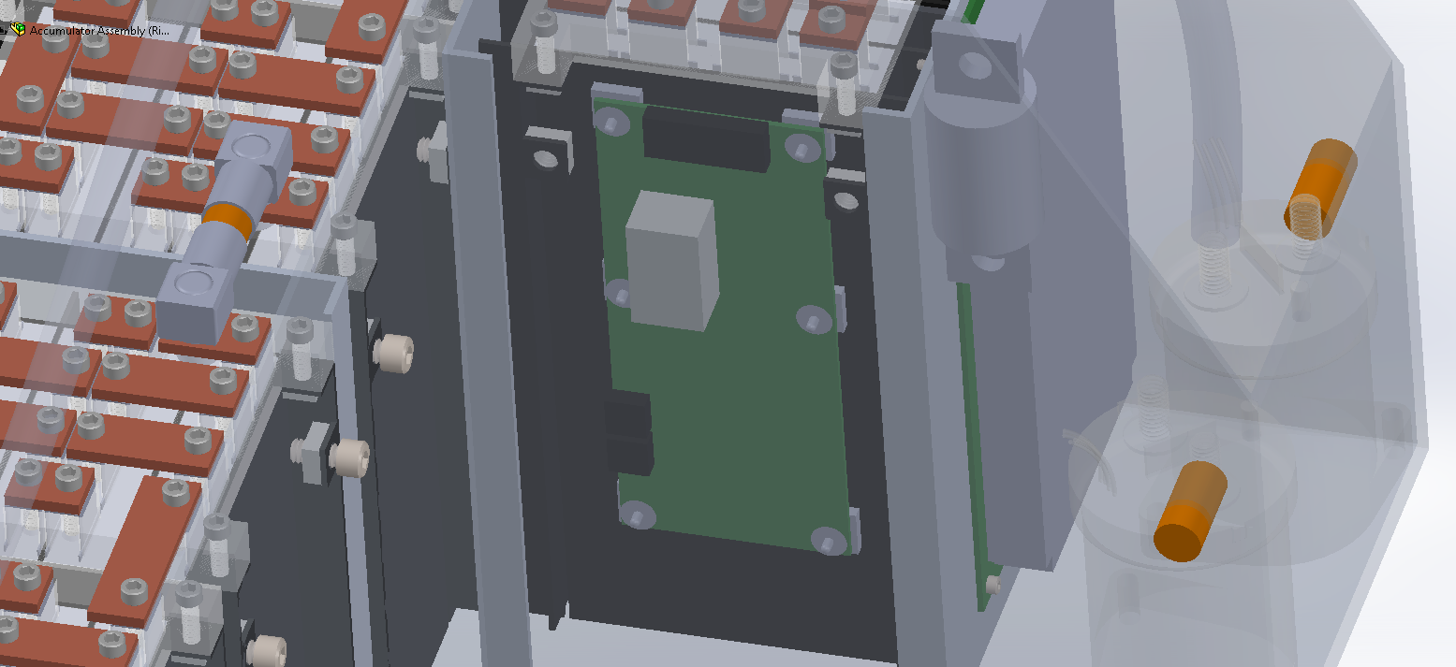

## Inertia Switch

### Description(type, operation parameters)

The inertia switch will be normally closed and will open to shut down the tractive system in the event of a crash. This is hooked up in series with the other safety switches that control the AIR’s so if it went off the tractive system would become unpowered. The driver will have the ability to depress the Sensata crash sensor to reset it.

|  |  |
| --- | --- |
| Inertia Switch type: | Sensata Resettable crash sensor |
| Supply voltage range: | 10..36VDC |
| Supply voltage: | 24VDC |
| Environmental temperature range: | -40..105°C |
| Max. operation current: | 10A |
| Trigger characteristics: | 6g for 50ms / 11g for 15ms |

Table 2.4 Parameters of the Inertia Switch

### Wiring/cables/connectors/

The crash sensor will be rigidly mounted to the frame of the car near the bottom to ensure that it receives the full force of any vibration or impact using a mating connector and 18 AWG wire will be used for the electrical connections.

### Position in car

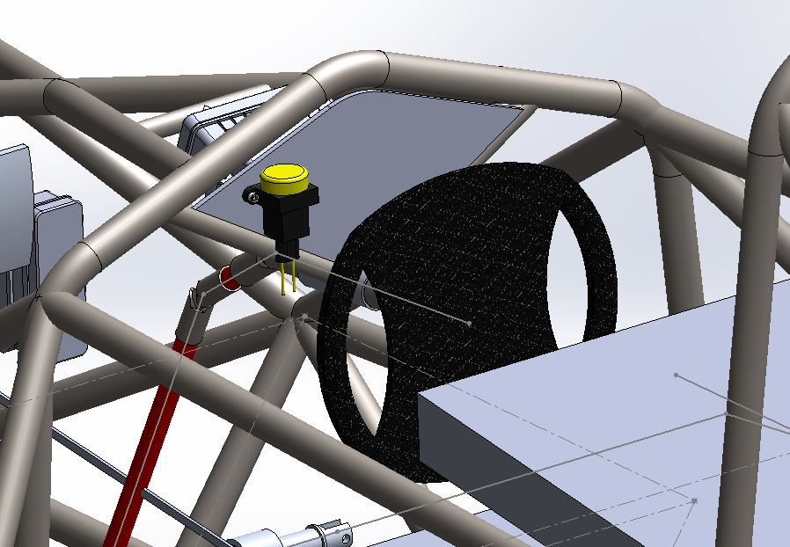

## Brake Plausibility Device

## Description/additional circuitry

The purpose of the brake plausibility system is to ensure that the brake pedal does not pass a certain threshold if the motors are being driven. It will work by usinga potentiometer on the brake pedal to measure braking and a current sensor on the connection between the accumulator and motor controllers to measure the current. These measured values will be compared to pre-calculated constant threshold values supplied from adjustable voltage regulators. The current set point is at 16.6A.

|  |  |
| --- | --- |
| Brake sensor used: | TD1000WWG070003D002P90 |
| Current Sensor used: | MLX91205 |
| Supply voltages: | 5V |
| Maximum supply currents: | 5mA and 11mA |
| Operating temperature: | -40..100 °C |
| Output used to control AIRs: | Open a relay |

Table 2.5Torque encoder data

## Wiring

The brake plausibility system takes a 9V power input from the LV power system, along with 0-5Vdigital sensor input from the brake pedal sensor and the current sensor on the motor supply. The only output is the on or off 24v relay power that goes to the shutdown circuit. The reset of this system is done by power cycling the GLVS or hitting the reset button.

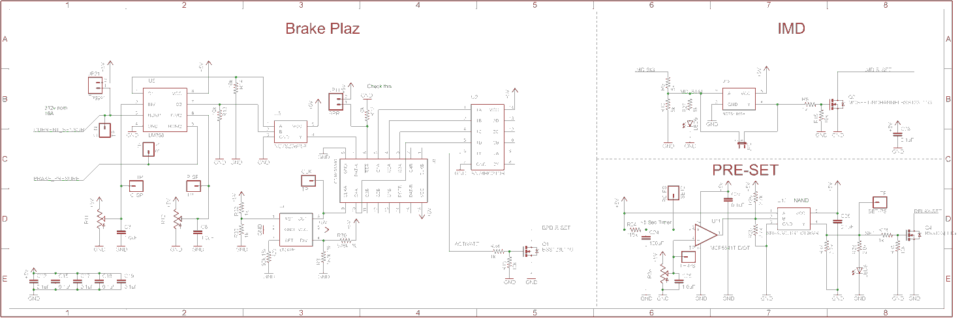

## Position in car / mechanical fastening / mechanical connection

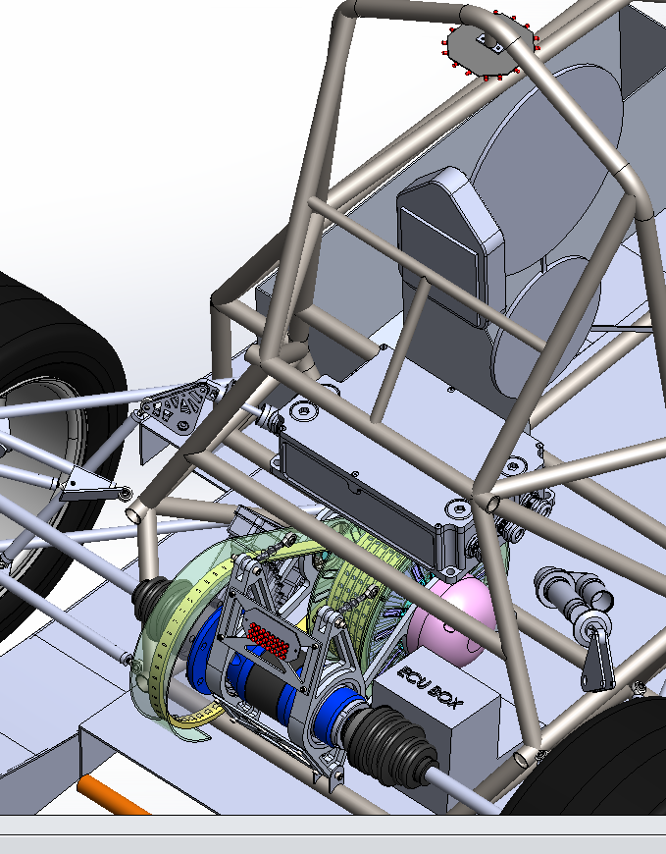

## Reset / Latching for IMD and BMS

### Description/circuitry

If the IMD or BMS becomes tripped, the latching relays will open. A GLVS power cycle will reset these systems or pushing the reset button. The latching relays are set by the PRE-SET circuit. Below is the IMD hardware Safety System. The BMS is done in software but is only reset (turned on) during startup.



### Wiring/cables/connectors

The BMS and IMD relay is wired into the shutdown system in series with other safety systems. This is wired with AWG 16 wire. The BMS has a relay on the PCB that it can trip to open the shutdown circuit.

### Position in car



## Shutdown System Interlocks

### Description/circuitry

The interlocks are achieved by using sense low voltage isolated pins in the connectors to detect open or closed connections. The AIR’s power travel threw them. We have interlocks between the HVD, connector between the battery box and the car, and the connector between the two accumulators.

### Wiring/cables/connectors

Describe wiring, show schematics, describe connectors and cables used and show use ful data regarding the wiring.

### Position in car

## Tractive system active light

### Description/circuitry

The TSAL consists of 16 LED’s mounted every 45 deg. to form an octagon with 2 LED’s on each side. The 3 Hz flashing frequency is driven by a 555 timer.

Additionally fill out the table:

|  |  |
| --- | --- |
| Supply voltage: | 24VDC |
| Max. operational current: | 40mA |
| Lamp type | LED |
| Power consumption: | 1 W |
| Brightness | 1000 Lumen |
| Frequency: | 3Hz |
| Size (length x heightx width): | 4 inches x .75 inches x 4 inches |

Table 2.6 Parameters of the TSAL

### Wiring/cables/connectors

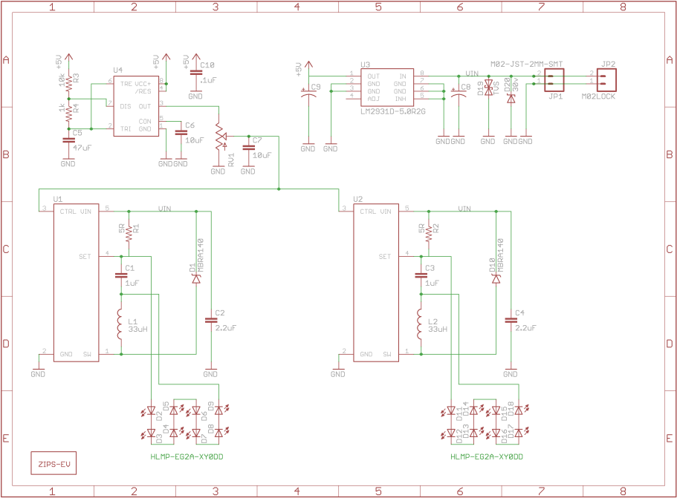

### Position in car

The TSAL is mounted to the bottom of the main roll hoop as required by the rules. It will be mounted with a metal bracket.



## Measurement points

### Description

4mm red and black banana jacks will be used to allow tractive system voltage measurement.

### Wiring, connectors, cables

AWG 22 wire will connect the banana jacks in line with a 10kOhm resistor to the HV+ and HV- connections after the AIR’s.

### Position in car

.

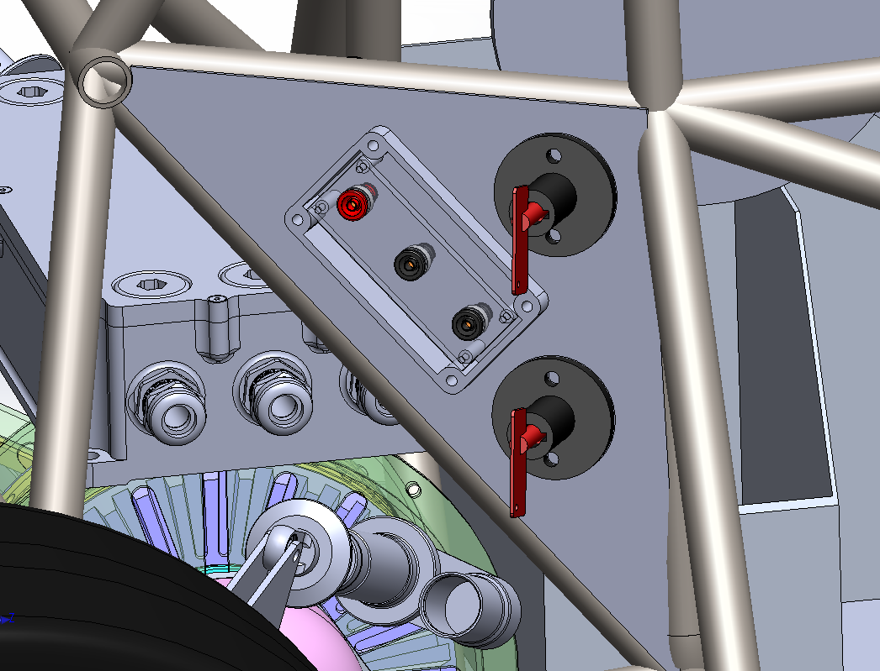

## Pre-Charge circuitry

### Description

The Pre-Charge system of the car is used to equalize the potential of the across the AIR switch and both battery packs. Pre-Charge started when the safety system is all clear of faults. This includes the ECU clearing its fault and setting the ready to drive relay. Bottom or negative really turns on. Then the Pre-Charge relay in series with a 150 ohm resistor turns on and waits 2.5 seconds. This 2.5 second delay originates from the safety system board. This is set by an RC timer. After the 2.5 seconds are up, the Pre-Charge relay stays on and the AIR’s turn on shorting out the Pre-Charge resistor. During Pre-Charge, the car is acquiring data from the motor controller to verify voltage is present and increasing on the battery input to the device. If this doesn’t happen, the car will trip ECU safety stop and report error code.

### Wiring, cables, current calculations, connectors

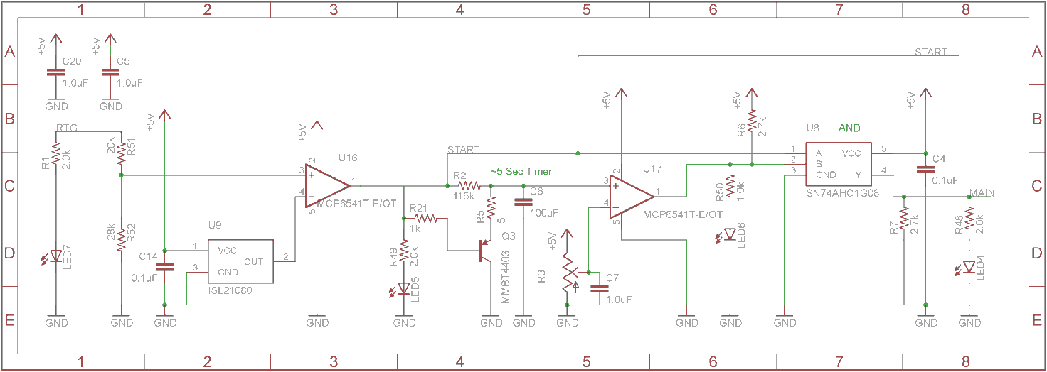

Formula = $1-{294.2}^{\frac{-t}{150*0.00088}}$

Formula = $\frac{294.2}{150}{294.2}^{\frac{-t}{150*0.00088}}$

|  |  |
| --- | --- |
| Resistor Type: | WFH160L150JE - Wirewound |
| Resistance: | 150Ω |
| Continuous power rating: | 160W |
| Overload power rating: | 160W |
| Voltage rating: | 600V |
| Cross-sectional area of the wire used: | 1.31mm² |

Table 2.7 General data of the pre-charge resistor

|  |  |
| --- | --- |
| Relay Type: | 5501-24-1 |
| Contact arrangment: | SPST-NO |
| Continuous DC current: | 3A |
| Voltage rating | 7500VDC |
| Cross-sectional area of the wire used: | 1.31mm² |

Table 2.8 General data of the pre-charge relay

### Position in car

## Discharge circuitry

### Description

Our system requires a discharge system to get the capacitive energy out of the motor controller. Our system uses multiple (3) resistors to drop the energy. We are able to discharge the energy in about 1.8 seconds. The relay is normally closed and when the AIR is powered up they move to the open position.

Formula = $\frac{294.2}{450}{2.7182}^{\frac{-t}{150*0.00088}}$

Formula = $294.2*{2.7182}^{\frac{-t}{150*0.00088}}$

|  |  |
| --- | --- |
| Resistor Type: | WFH160L150JE - Wirewound |
| Resistance: | 450Ω |
| Continuous power rating: | 160W |
| Overload power rating: | 160W |
| Voltage rating: | 600V |
| Maximum expected current: | 0.7A |
| Average current: | 0.4A |
| Cross-sectional area of the wire used: | 1.31 mm² |

Table 2.9 General data of the discharge circuit

|  |  |
| --- | --- |
| Relay Type: | 5502-24-1 |
| Contact arrangment: | SPST-NC |
| Continuous DC current: | 3A |
| Voltage rating | 7500VDC |
| Cross-sectional area of the wire used: | 1.31 mm2 |

Table 2.10 General data of the dis-charge relay

### Position in car

.

## HV Disconnect(HVD)

### Description

The HVD is a 1-1587987-7 model from TE connectivity. It is a member of their Series B connector family and is capable of 630Amps and 450V.

### Wiring, cables, current calculations, connectors

EXRAD-FSX1X 1 couple.TE connectivity 1-2103172-7.

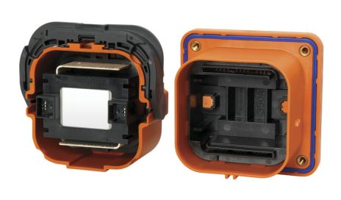

### Position in car

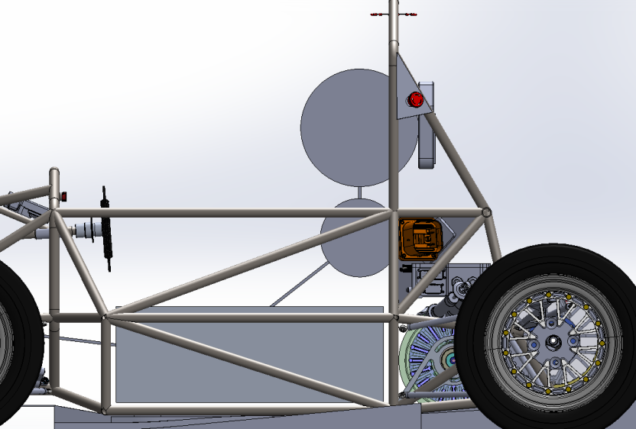

## Car Back (HVD)

## Ready-To-Drive-Sound (RTDS)

### Description

Upon the Accumulator Isolation Relays closing, and the motor controllers turning on, a12V car horn will turn on to notify all that the vehicle is ready to drive. The horn (Piezzo) is driven by a mosfet driver. The signal that drives the buzzer is from the ECU.

### Wiring, cables, current calculations, connectors

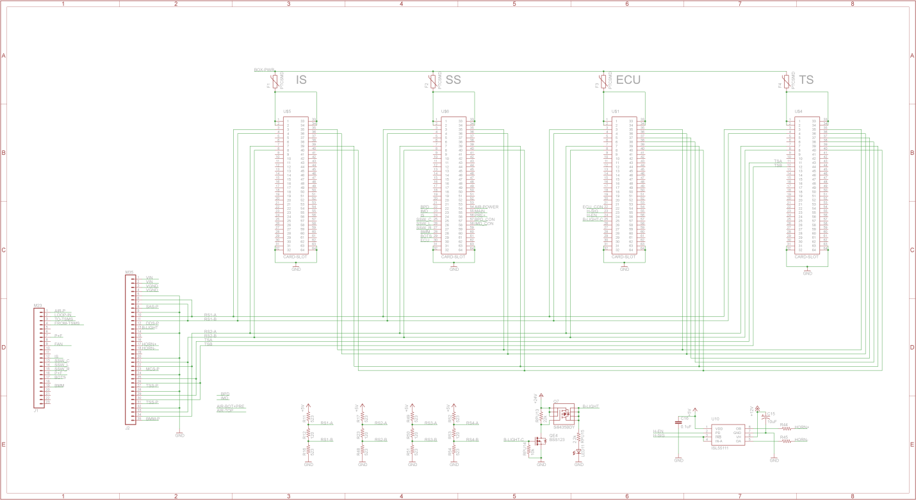

AWG 22wire is used between the controller and piezo.

### Position in car

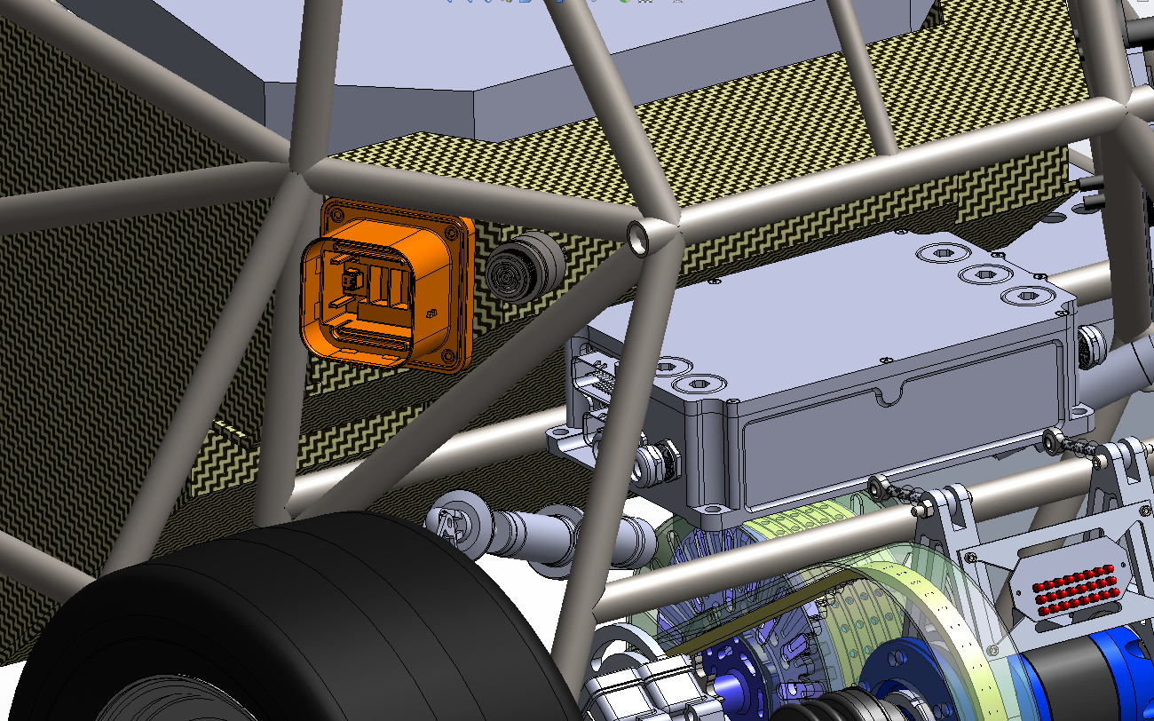

# Accumulator

## Accumulator pack 1

### Overview/description/parameters

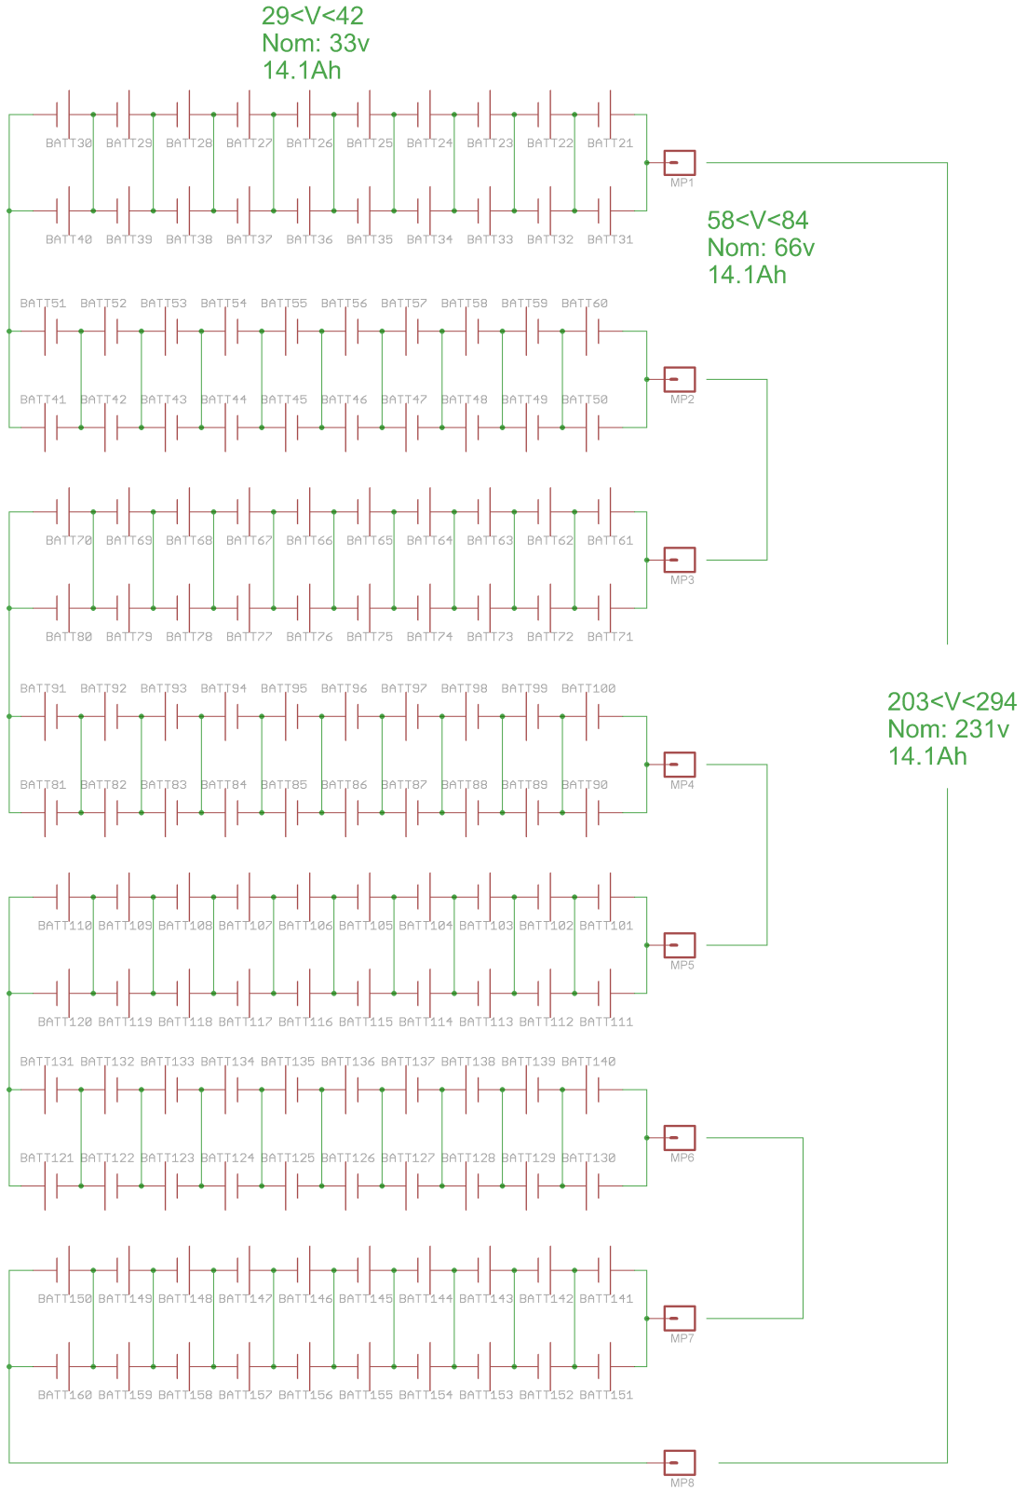

x2

Right (Box1-70s2p)

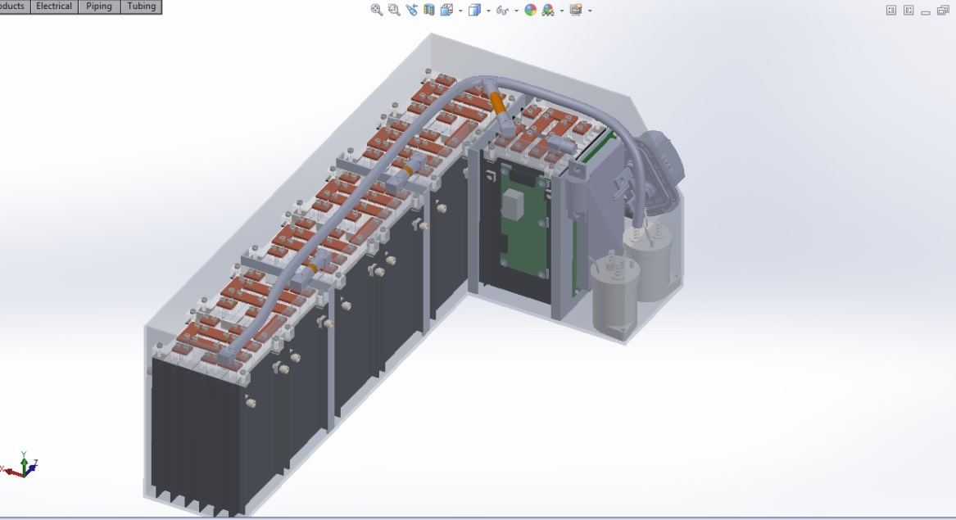

Left (Box2-70s2p)

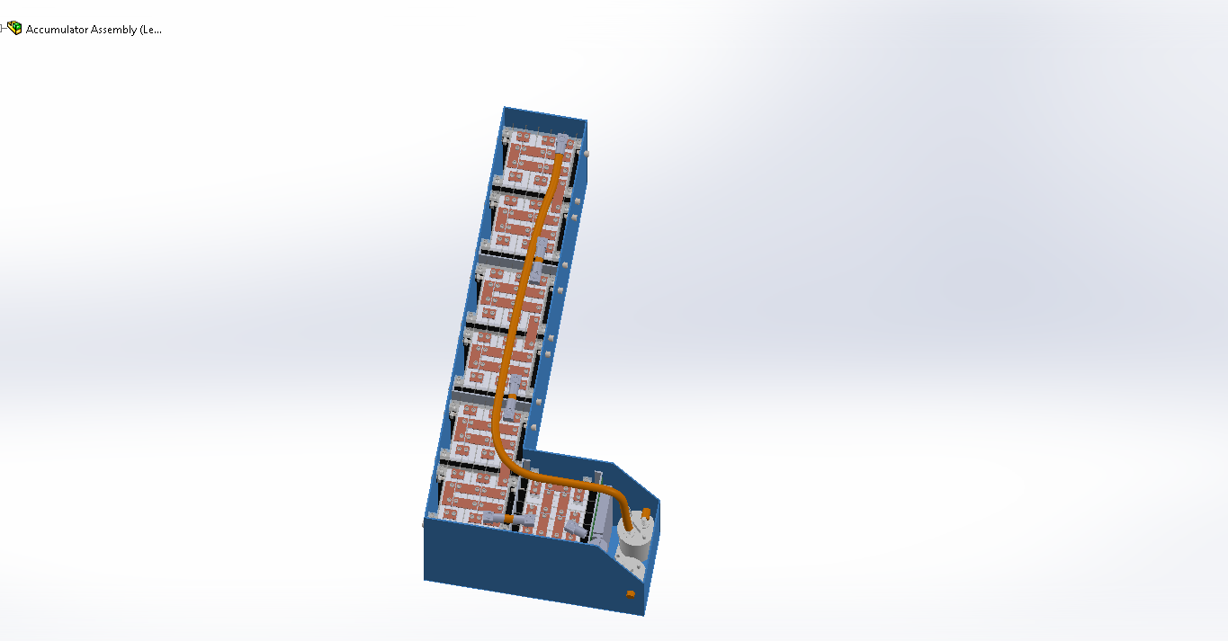

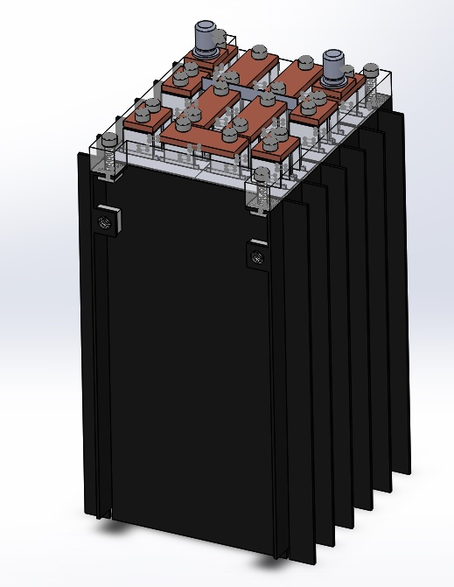

|  |  |
| --- | --- |
| Maximum Voltage: | 294VDC |
| Nominal Voltage: | 231VDC |
| Minimum Voltage: | 203VDC |
| Maximum output current: | 580A for 2s |
| Maximum nominal current: | 280A |
| Maximum charging current: | 28A |
| Total numbers of cells: | 280 |
| Cell configuration: | 70s4p |
| Total Capacity: | (7.05Ah)(3.3V)(3600j/Wh)(280cells)x10^-6=23.45MJ  (7.05Ah)(3.3V)(280cells)=6,514.2 Watt-hours |
| Number of cell stacks < 120VDC | 8 |

Table 3.1 Main accumulator parameters

### Cell description

|  |  |
| --- | --- |
| Cell Manufacturer and Type | Melasta SLPB9145180 |
| Cell nominal capacity: | 7.05 Ah |
| Maximum Voltage: | 4.2 V |
| Nominal Voltage: | 3.3V |
| Minimum Voltage: | 3.0V |
| Maximum output current: | 25C for 10s |
| Maximum nominal output current: | 20C |
| Maximum charging current: | 2C |
| Maximum Cell Temperature (discharging) | 60°C |
| Maximum Cell Temperature (charging) | 45°C |
| Cell chemistry: | LiPo |

Table 3.2 Main cell specification

### Cell configuration

Each accumulator contains 140 cells. The cells are separated in 7 segments containing 20 cells each. The segments are in a 10s2p arrangement. Each parallel cell in the segment is back to back.

### Cell temperature monitoring

Every cell will be monitored for temperature. We do this by putting an NTC resistor between the cells. Each battery segment PIC will monitor the cell temperature.

### Battery management system

280 cells will be monitored by the BMS that we made ourselves. 14 Slave devices with microcontrollers will communicate with one Master. This communication is done over RS485 and is isolated at each cell and master. The BMS is capable of opening a relay in the shutdown circuit to open the AIRs in the case of an error. At a minimum cell voltage of 3 and a maximum of 4.2, the BMS will take actions to bypass the affected cell(s) and shutdown the tractive system if necessary. The BMS also reacts to temperature problems at 75°C. The BMS can also measure current and trigger the safety system. The BMS shuts down the tractive system via a relay that is tied into the safety loop. If shut down, it would trip the safety system and the car would shut down. These boards are linked with IDC-8 ribbon cable. This allows for hot swapping boards. The slave boards are mounted to the positive battery terminal posts with nuts and lock washers. There is a wire leaving the board to go to the battery ground that is used to sense the voltage it is being powered off of.

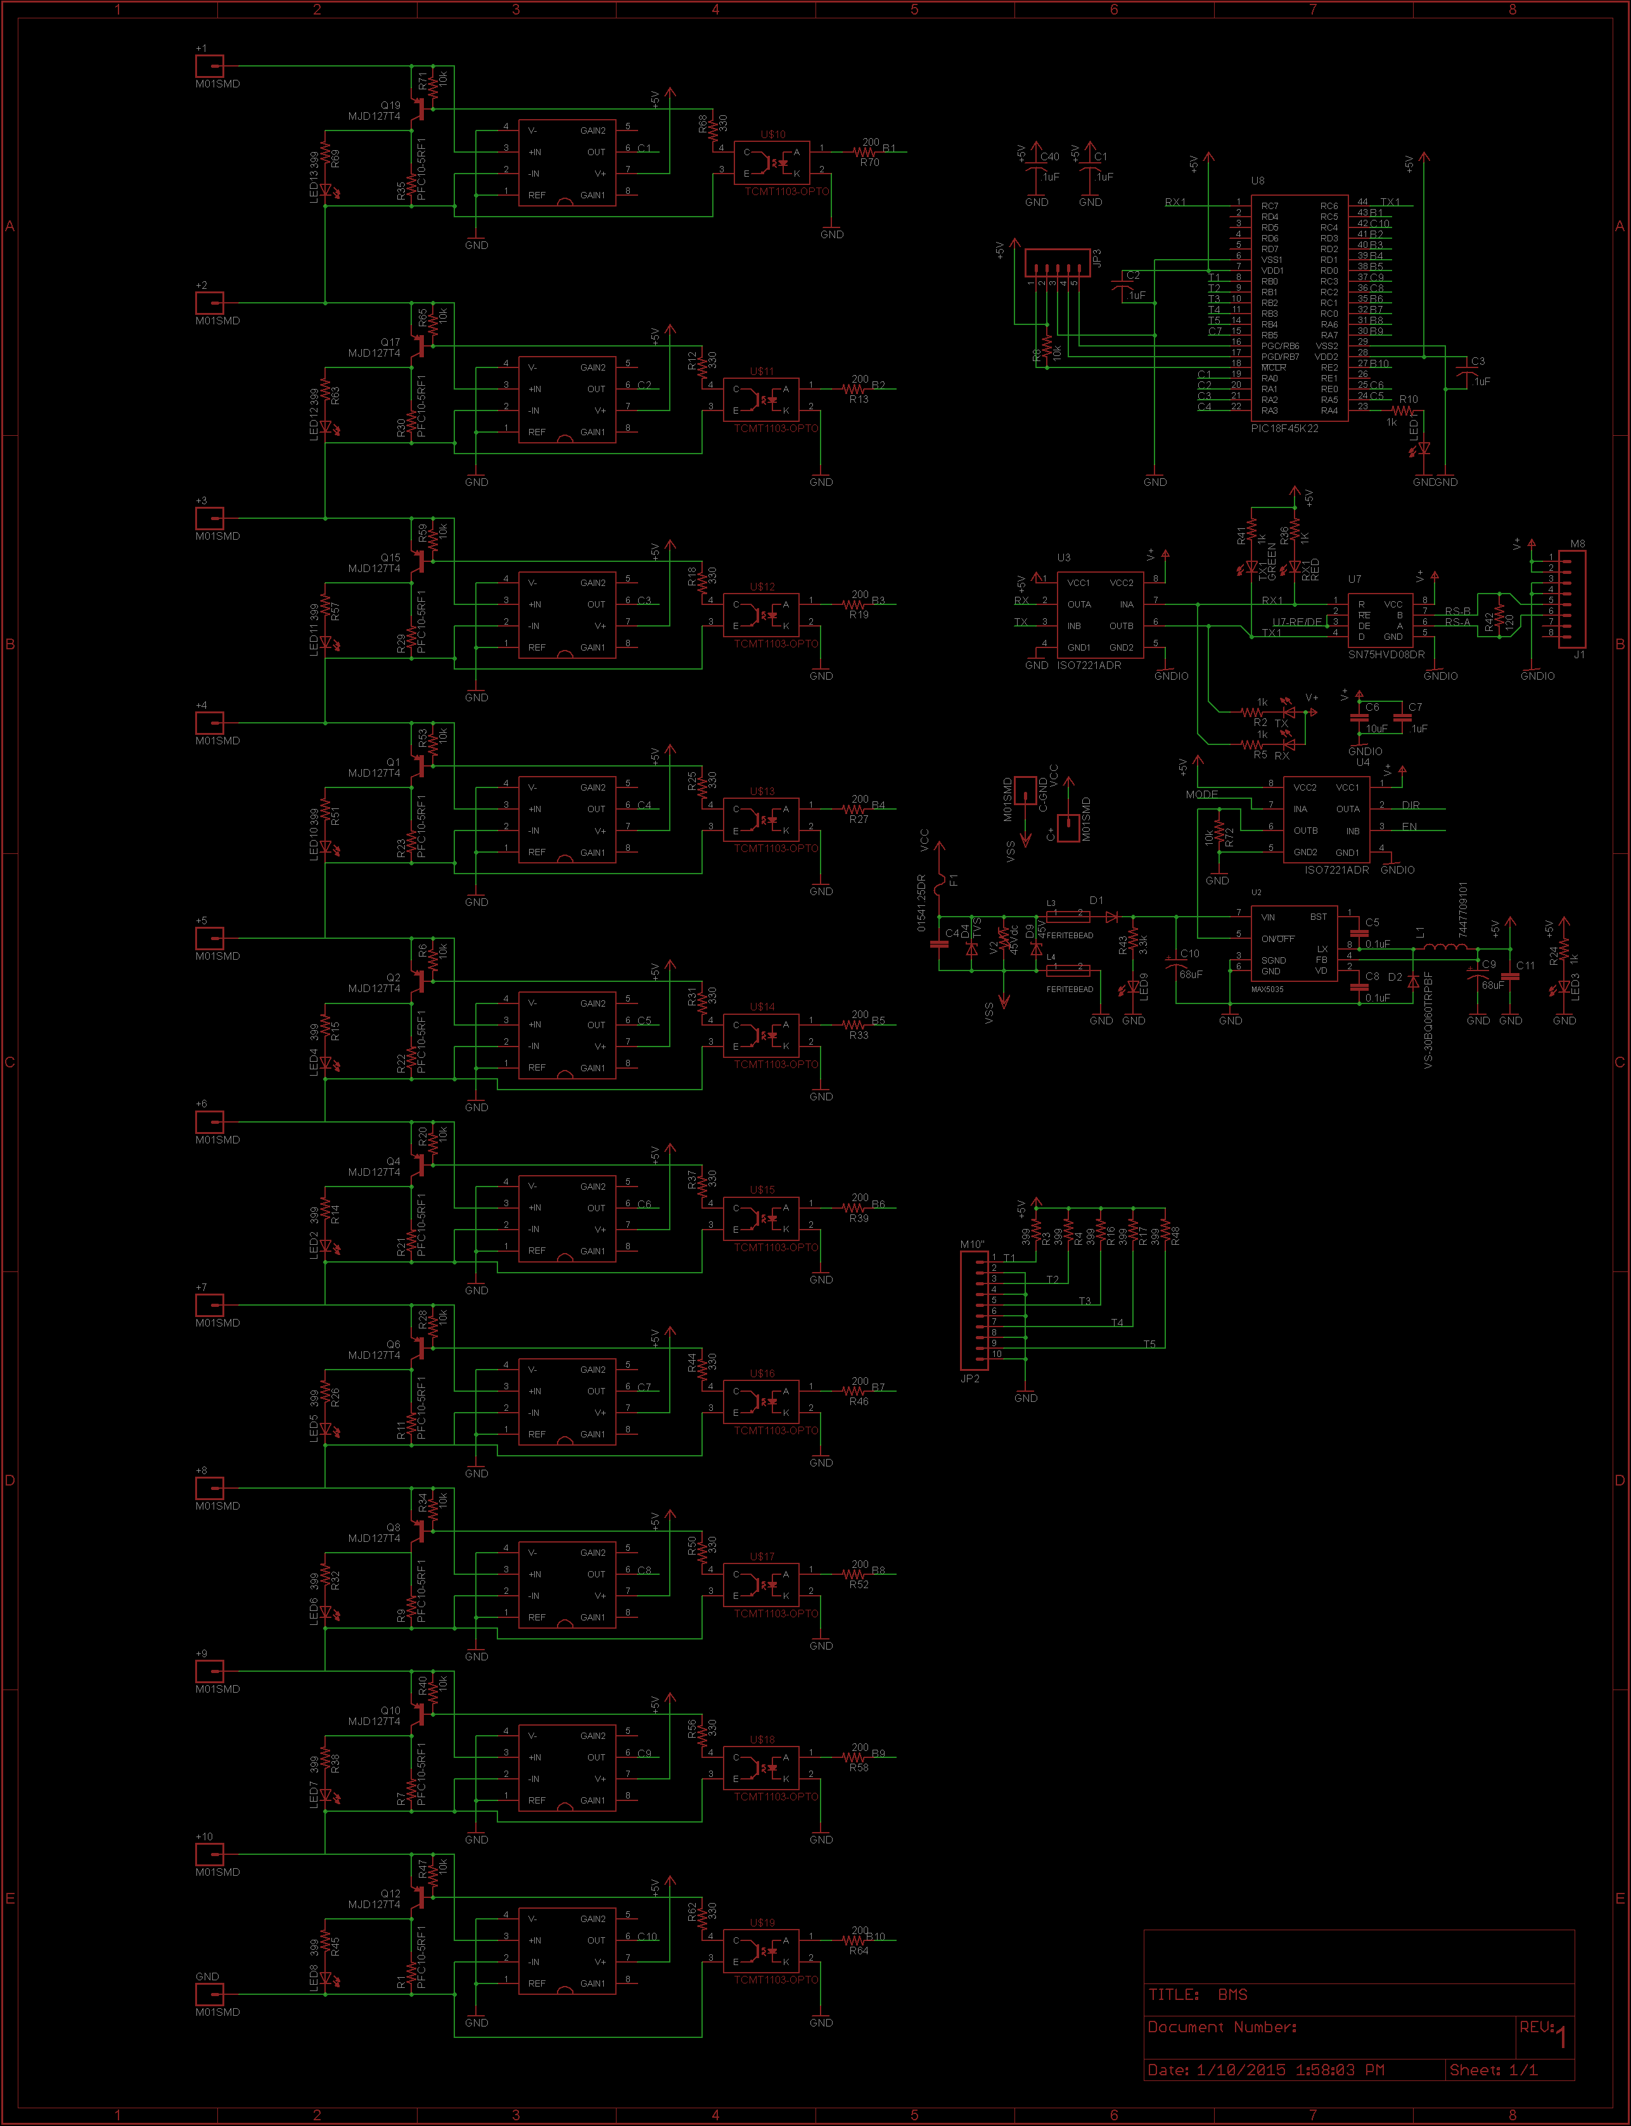

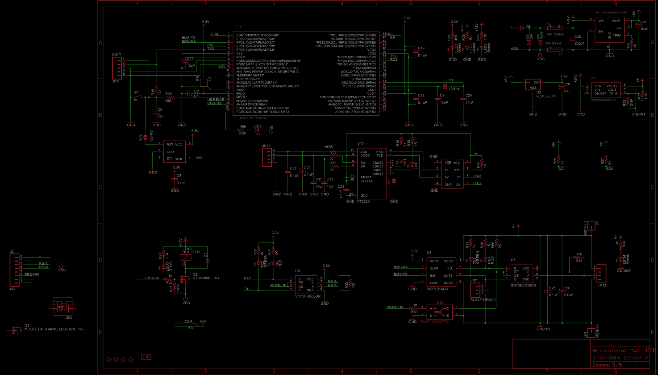

### Accumulator indicator

The accumulator indicator is an LED that will be attached to the battery enclosure to indicate that the pack is active. This indicator will be wired across the first and last AIR’s, so that it is powered when there is voltage on the vehicle side of the accumulator container. The wire used for this AWG 22.

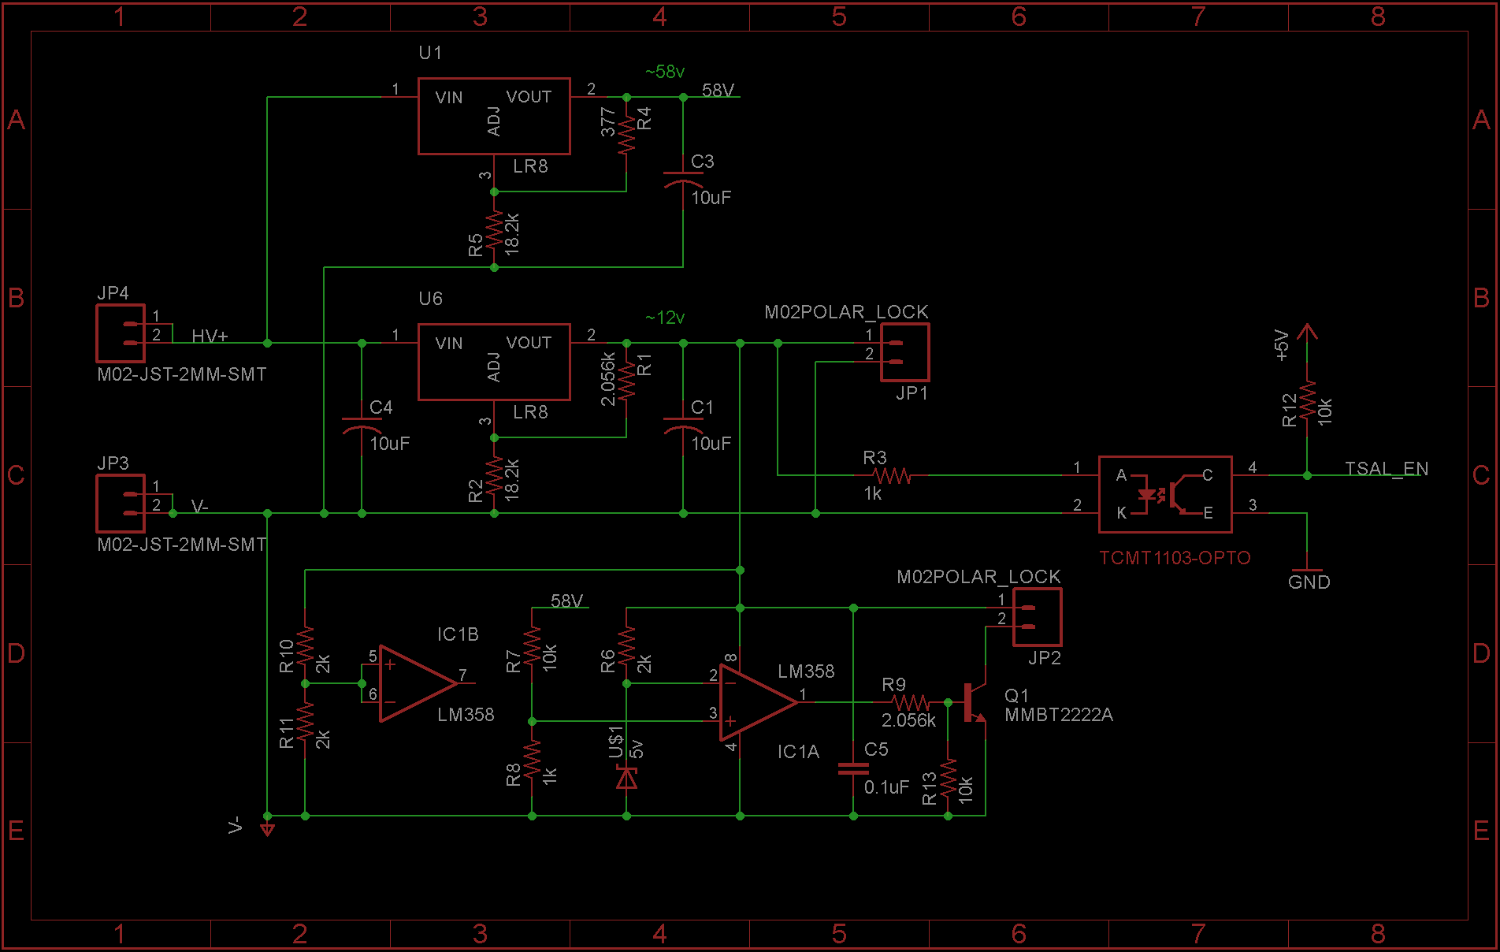

### Wiring, cables, current calculations, connectors

|  |  |
| --- | --- |
| Wire type: | Champlain Exrad xlx2x |
| Current rating: | 255A |
| Maximum operating voltage: | 1000V |
| Temperature rating: | 240 °C |
| Wire type: | Champlain Exrad xlx2x |
| Wire connects the following components: | Cell and BMS |

Table 3.3 Wire data of company A, 0.205 mm²

### Accumulator insulation relays

|  |  |
| --- | --- |
| Relay Type: | TE 5-1618388-5 |
| Contact arragment: | SPST |
| Continous DC current rating: | 500A |
| Overload DC current rating: | N/A |
| Maximum operation voltage: | 900VDC |
| Nominal coil voltage: | 24VDC |
| Normal Load switching: | Make and break up to 500A |
| Maximum Load switching | 10 times at 1500A |

Table 3.4 Basic AIR data

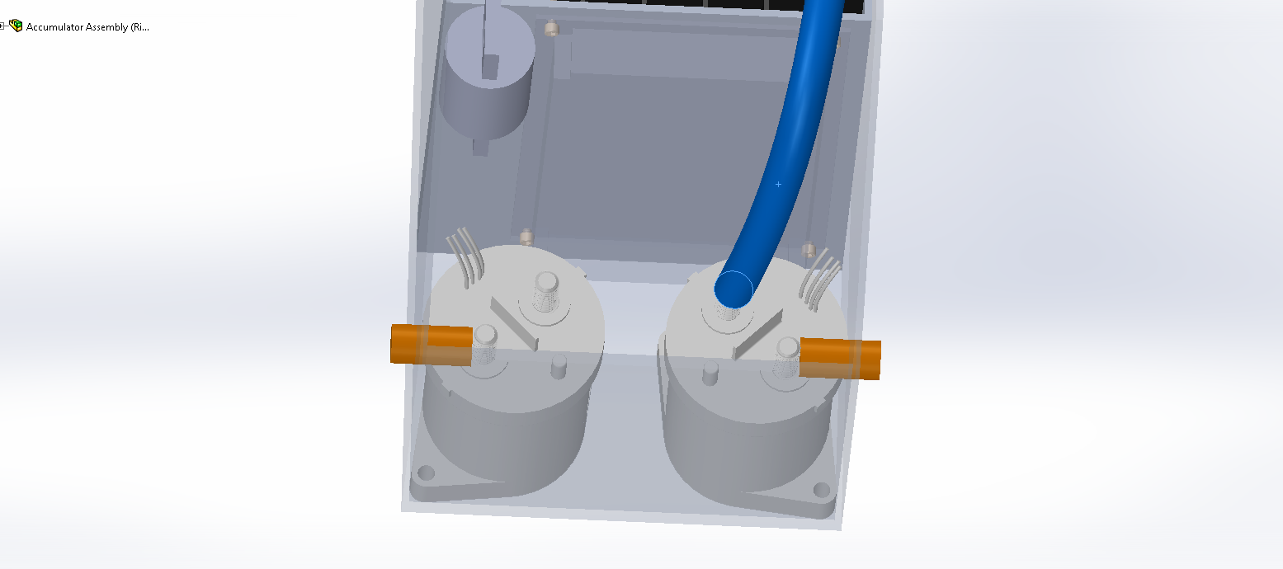

### Fusing

Two fuses will be used. one on each accumulator.

|  |  |
| --- | --- |
| Fuse manufacturer and type: | Littelfuse, Class T |
| Continous current rating: | 150A |
| Maximum operating voltage | 300VDC |
| Type of fuse: | High speed |
| I2t rating: | 1500A2s at 450VDC |
| Interrupt Current (maximum current at which the fuse can interrupt the current) | 20000A |

Table 3.5 Basic fuse data

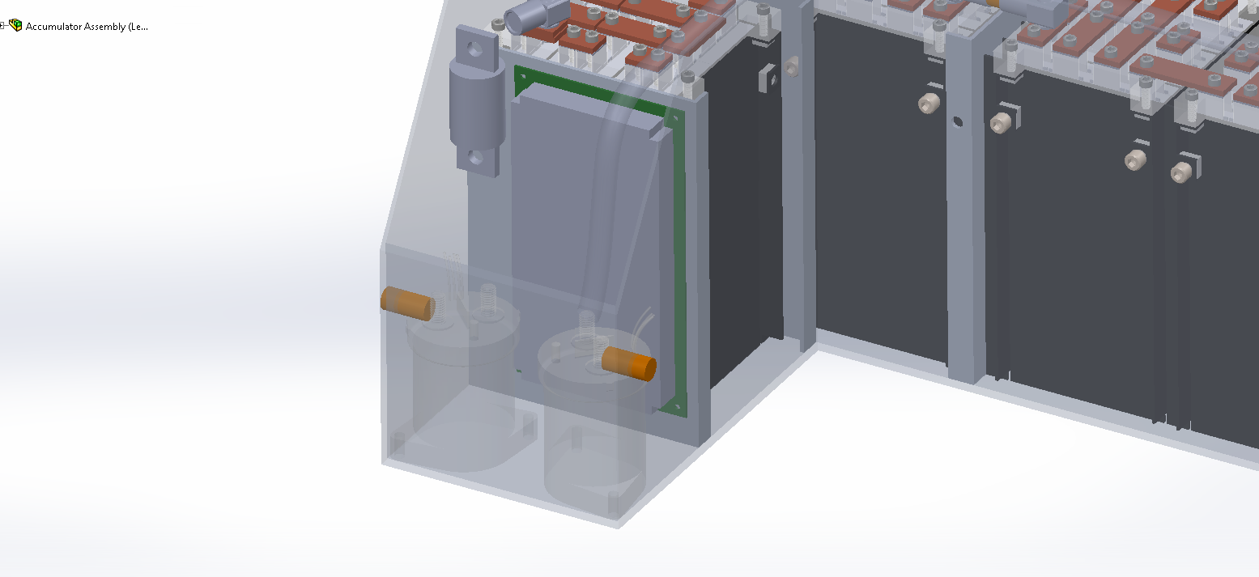

|  |  |  |  |  |
| --- | --- | --- | --- | --- |
| Location | Wire Size | Wire Ampacity | Fuse type | Fuse rating |
| Cells to AIRs | 2 AWG | 255 | MNO Fuse | 245 |
| AIR to Motor controller | 2 AWG | 255 | MNO Fuse | 245 |
| AIR to TSAL | 24 AWG | 3.5 | EFG Fuse | 0.5 |
|  |  |
| Cells to BMS | N/A |  |  |  |

Table 3.6 Fuse Protection Table

### Charging

The battery charging will use the battery management system to control the charger. The BMS-master by default is not able to talk to the charger directly and control the AIR's.. We designed a charging control adapter board that hosts the interfaces and isolation necessary to follow the rules of the competition. This board also hosts the safety system for the IMD, control relays, lights and LCD display.

|  |  |
| --- | --- |
| Charger Type: | SmartCharge-12000 |
| Maximum charging power: | 12kW |
| Maximum charging voltage: | 350V |
| Maximum charging current: | 70A |
| Interface with accumulator | serial communication |
| Input voltage: | 120-230 VAC |
| Input current: | Up to 50A |

Table 3.7 General charger data

### Mechanical Configuration/materials

### Position in car

The Charger is not in the car. We are building a charging cart to hold the external equipment.

## Accumulator pack 2

See Accumulator pack 1

# Energy meter mounting

## Description

Energy Meter will be connected between the ground of the accumulator and motor controller. It will measure the total energy used and calculate the efficiency.

## Wiring, cables, current calculations, connectors

All connections to the accumulator, the motors, and the energy meter are all Exrad XLE 2 cable

## Position in car

ProvideCAD-renderingsshowingallrelevantparts.Markthepartsintherendering,ifnecessary.

# Motor controller

## Motor controller 1

### Description, type, operation parameters

The PM100DX from Rinehart Motion Systems we are using are permanent magnet brushless AC motor controllers. They are capable of 0-360V and 300Arms. The motor controller are commanded via analog signals sent by our self-designed motor controller PCB (MCS). It communicates over a RS485 communication bus from the ECU The motor controllers also control the regenerative braking of the car. This is set from hardware controlled by our software. The controllers are isolated. Because of that, nothing connecting to them needs isolated from chassis ground.

|  |  |
| --- | --- |
| Motor controller type: | RMS PM100DX brushless AC |
| Maximum continous power: | 108kW |
| Maximum peak power: | 126kW for 30s |
| Maximum Input voltage: | 360VDC |
| Output voltage: | 250VAC |
| Maximum continuous output current: | 300Arms |
| Maximum peak current: | 350Arms for 30s |
| Control method: | analog signal |
| Cooling method: | water |
| Auxiliary supply voltage: | 12VDC |

Table 5.1 General motor controller data

### Wiring, cables, current calculations, connectors

All connections to the accumulator, the motors, and the energy meter are all Exrad XLE 2 cable. The motor controller will do all of our shield grounding for us on the High power cable.

|  |  |
| --- | --- |
| Wire type: | Champlain Exrad xlx2x |
| Current rating: | 255A |
| Maximum operating voltage: | 1000V |
| Temperature rating: | 240 °C |

Table 5.2 Wire data

### Position in car

## Car Back (TSAL, MC, ECU Box)

## Motor controller 2

…

N/A

.

# Motors

## Motor 1

### Description, type, operating parameters

|  |  |
| --- | --- |
| Motor Manufacturer and Type: | Enstroj EMRAX228 HV |
| Motor principle | Brushless Synchronus Three Phase AC |
| Maximum continuous power: | 45kW |
| Peak power: | 100kW for 3s |
| Input voltage: | 50-600Vdc |
| Nominal current: | 115A |
| Peak current: | 240A |
| Maximum torque: | 240Nm |
| Nominal torque: | 125Nm |
| Cooling method: | Water |

Table 6.1 General motor data

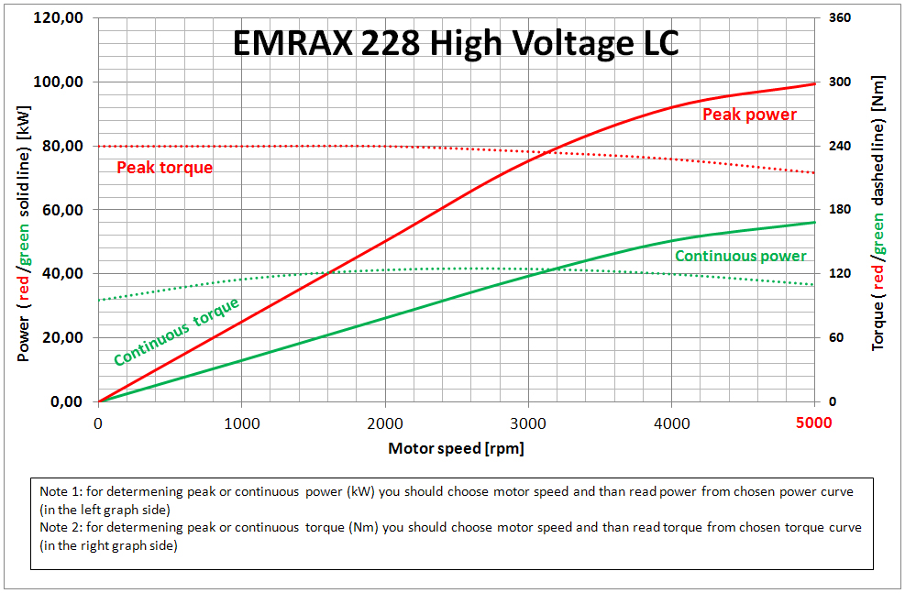

### Wiring, cables, current calculations, connectors

Wiring to the motor U, V and W high power connections use 2 AWG cable. We will be using 90 degree wire terminals and bolt them to the motor terminals.

### Position in car



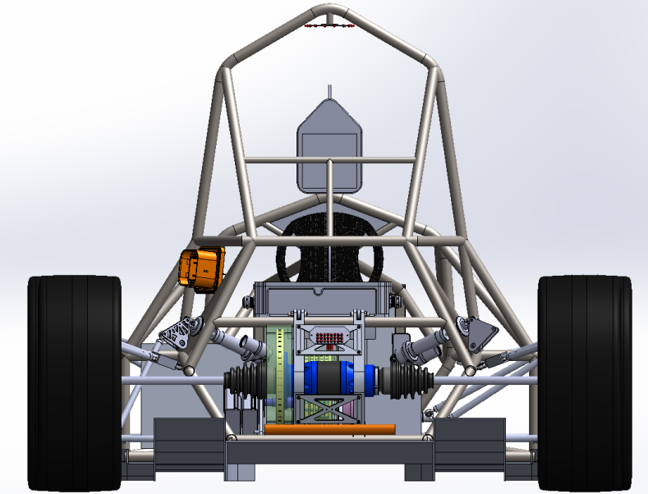

## Motor 2

N/A

# Torque encoder

## Description/additional circuitry

The two MHL1421 RV-50 sensors are linear displacement sensor. They will be connected to the throttle pedals of the vehicle. As the pedal moves the sensor will slide with the pedal and provide an analog output to the system. That output will be sent as an input to a conditioning circuit. Once conditioned, the signal will be sent to the main controller.

If an error occurs in the measuring of torque the main controller will shut the vehicle down. A number of errors could occur. If the output communication is lost to the controller the car will be shutdown. If at any time the conditioning circuit is shorted or becomes open the controller will see the loss of signal and shut the car down. If the outputs of the two potentiometers differ by more than 10% the vehicle will be shutdown as stated in the rules. Lastly, if either of the sensors is physically damaged or disconnected from the pedal the controller will see the loss of signal and shut the vehicle down.

|  |  |
| --- | --- |
| Torque encoder manufacturer and type: | MHL1421 RV-50 |
| Torque encoder principle: | potentiometer |
| Supply voltage: | 5V |
| Maximum supply current: | 15mA |
| Operating temperature: | -40..125 °C |
| Used output: | 0-5V |

Table 7.1 Torque encoder data

## Torque Encoder Plausibility Check

To check consistency on the signal going into our car algorithms, we installing pull down on the input on the SAS. So if one or all connections fail, we can sense the failure. This is done in software.

## Wiring

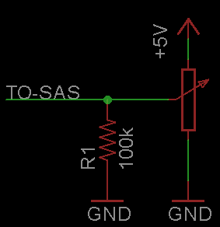

## Position in car/mechanical fastening/mechanical connection

# Pedal Box Photo_Side2Pedal Box Photo_ISO

# Overall Grounding Concept

## Description of the Grounding Concept

The chassis is made from conductive chrome-moly and will provide low resistance paths through the frame. The steering wheel will have a ground wire threw the disconnect to insure low resistance. Firewalls will be mounted to the car with tabs welded to the frame. The tabs will have paint removed to make a solid electrical connection to the firewall.

## Grounding Measurements

GLVMP location. GLV battery lead comes out and lands on a frame bolt.

# Firewall(s)

## Firewall 1

### Description/materials

The firewall will be made from aluminum sheet. This material is UL 94 V0 rated for thicknesses greater than or equal to ¼”.

### Position in car

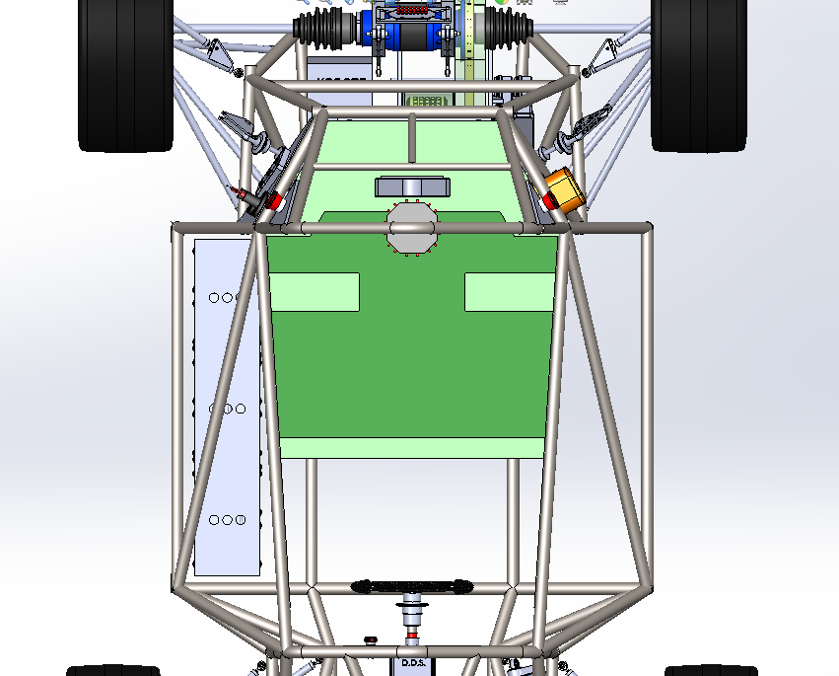

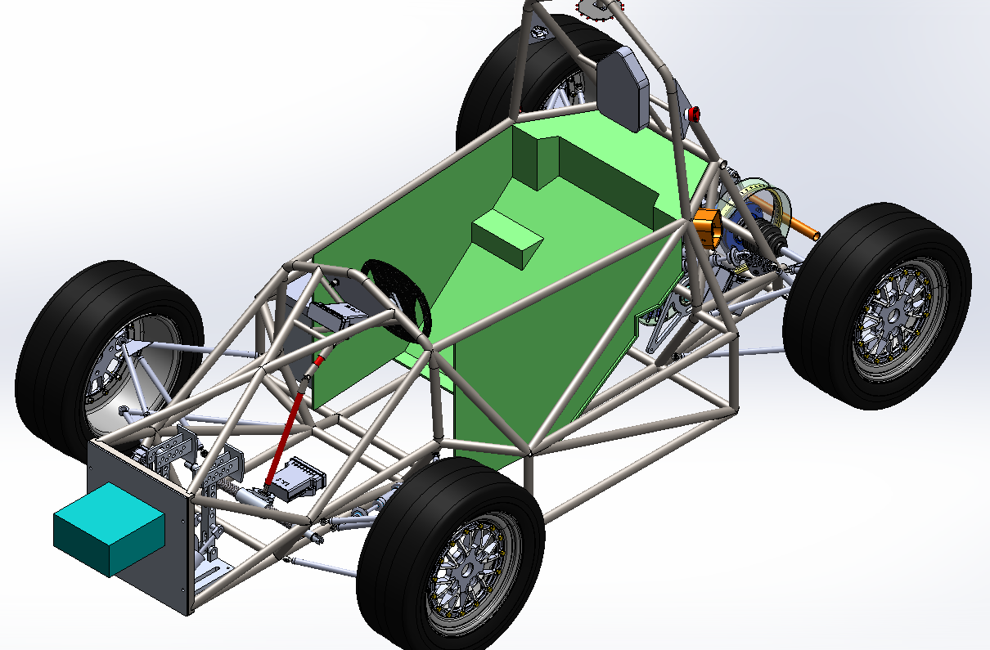

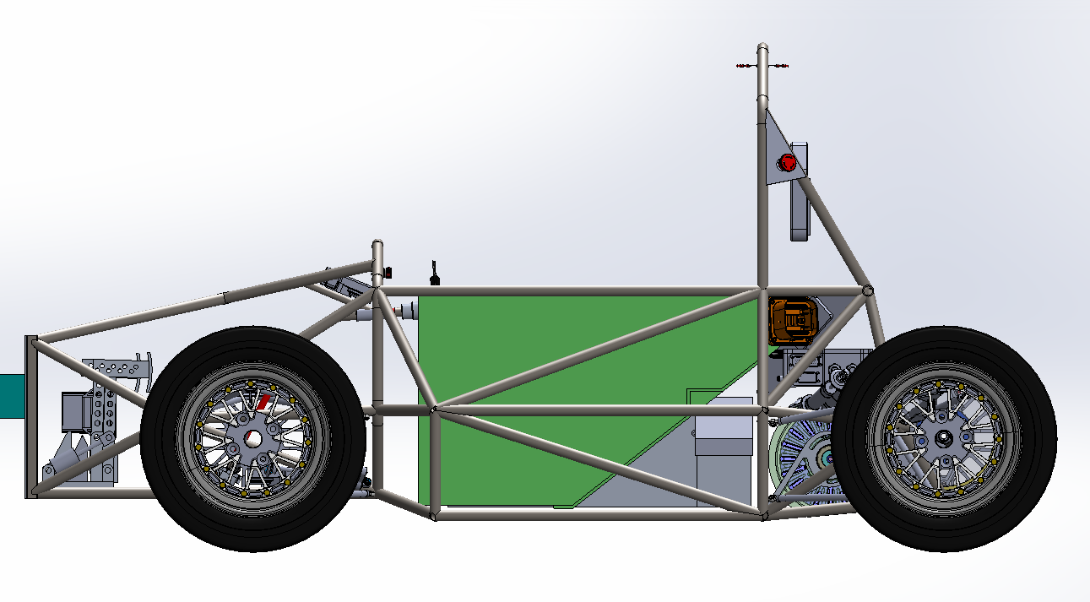

## Firewall 2

N/A

# Appendix

**Numbering according to chapter 1 to 10**

A data sheet for motor controller one for example has to have the numbering 11.10.5

Example appendix entry:

11.2.2 – Bender IR155-3203 IMD ratings

Referred from 2.1.1.

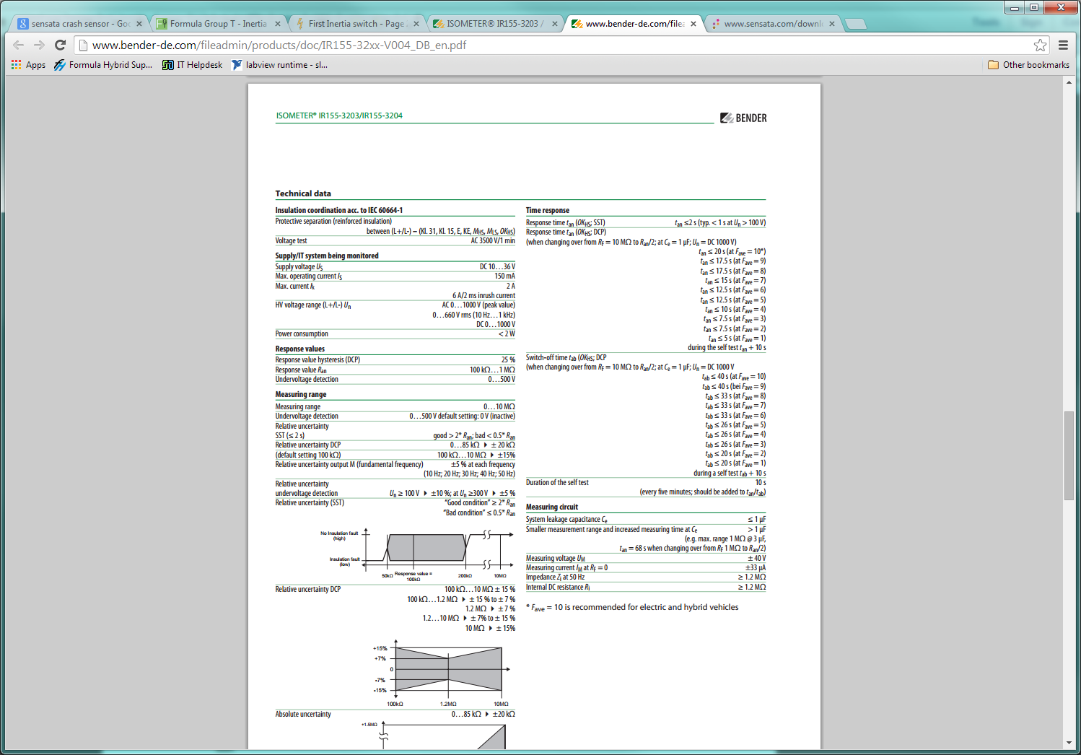

Complete data sheet located at:<http://www.bender-de.com/fileadmin/products/doc/IR155-32xx-V004_DB_en.pdf>